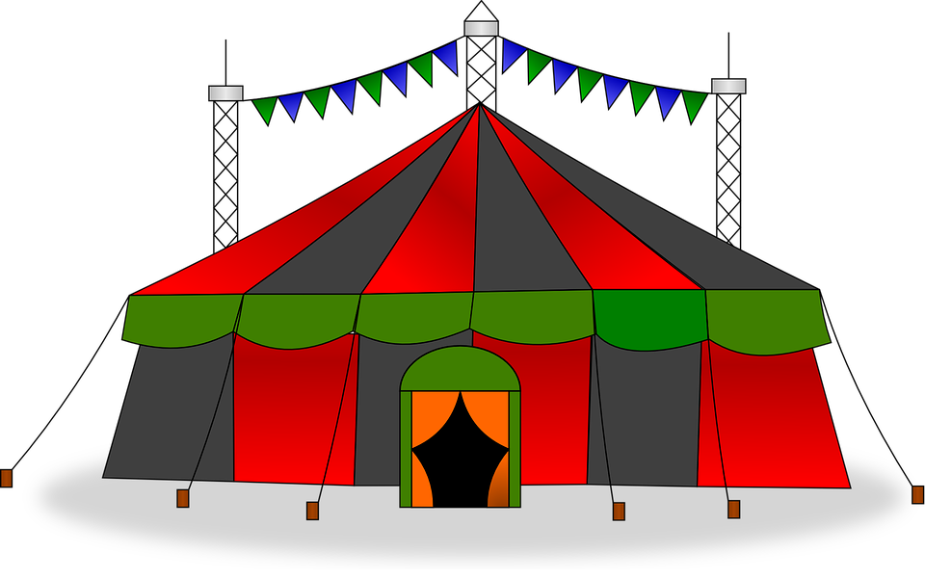

Children’s Books about  
 The Circus

Easy Readers:

* *Babar’s Little Circus  
   Star* - Laurent de Brunhoff
* *Word Bird’s Circus Surprise -* Jane Belk Moncure
* *C is for Clown -* Stan Berenstain

Juvenile:

* *Circus Mirandus* - Cassie Beasley
* *The Adventures of Nanny   
  Piggins -* R.A. Spratt
* *Big Top Flop* - Carolyn Keene

Picture Books:

* *The Circus Ship* - Chris Van Dusen
* *Olivia Saves the Circus -* Ian Falconer
* *Extraordinary Jane* - Hannah E. Harrison
* *Clifford at the Circus -* Norman Bridwell
* *Emeline at the Circus -* Majorie Priceman
* *If I Ran the Circus -* Dr. Seuss
* *Where’s Pup? -* Dayle Ann Dodds
* *A Small Surprise* - Louise Yates
* *Peppa Pig and the Backyard   
  Circus*